20MCA136 – NETWORKING & SYSTEM ADMINISTRATION LAB Dept. of Computer Applications

|  |
| --- |
| **Name: VYSHNAV SURESH**  **Roll No: 56**  **Batch: B**  **Date: 09-05-2022** |

**NETWORKING & SYSTEM ADMINISTRATION LAB**

**Experiment No.: 13**

**Aim**

Write a shell script to display current date and calender.

# Program

echo "Current date is $(date)" echo "Calender;"

cal

# Output screenshot

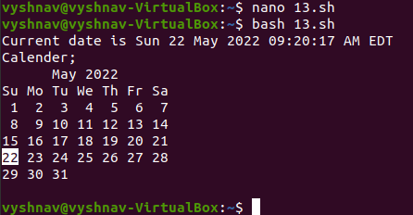

Amal Jyothi College of Engineering, Kanjirappally